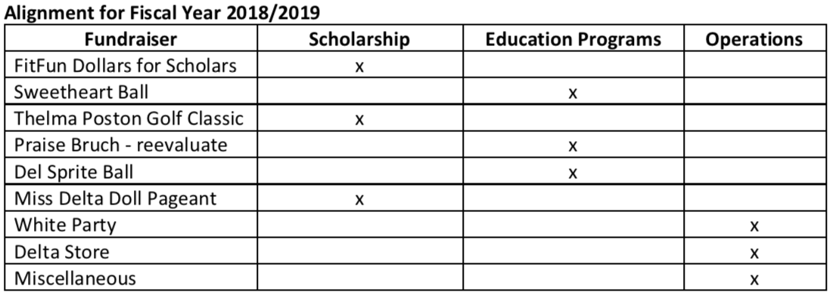
2019 / 2020 BUDGET REFERENCE – GENEERAL LIABILITY INSURANCE
excerpt from Finance Handbook

- Each committee chair that is having an event that involves non-members must submit the request for special events insurance coverage to the Program Planning Chair. The Program Planning Chair will work with the Treasurer and the insurance carrier to secure one policy for all chapter events.
i. General Liability Insurance
1. In additional to the General Liability Insurance based on the
number of chapter members, ADDITIONAL COVERAGE is required when the general public is invited to an activity. This insurance does not cover athletic events, co-sponsored events, events with liquor (additional insurance must be obtained).
3
Number of Attendees | Charge
0 to 250 | $100.00
251 to 500 | $200.00
501 to 750 | $300.00
751 to 1000 | $400.00
Professional Insurers and Associates
7700 Branch Avenue E104 - Clinton, MD 207-1658
(301)856-1810

