Reporting Committee: The Saginaw Pan-Hellenic Council

Committee Chair/Co-Chair: |  | Soror Tiffany Riggins
Committee Members Present:

Please limit your report presentation to no more than 3 minutes
Agenda Items:
Report details
*The 31st Fine Arts Competition for students in the sixth –twelfth grades was held on Saturday, Feb. 23, 2019 at Willie E. Thompson Middle School. The theme this year was Black Migrations.

Sorors please try to attend Pan-Hel events if possible. Remember we paid our dues for membership into the council. It doesn’t look good when other organizations have members present at Pan-Hel events and we don’t.

* The council is selling “Unity” themed T-shirts. The cost is $20 for sizes Small-Xl and $25 for sizes 2XL-4Xl. Please see Soror Tiffany Riggins to place your order immediately. The deadline to order shirts is Saturday, March 16, 2019. Shirts will not be sold after this date.

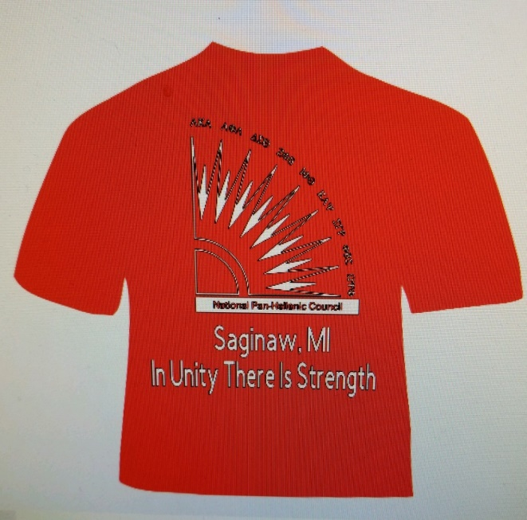

*Calendar Updates:
On 03-09-19, at 10:00-1:00 p.m. Youth Symposium for ages 8-18. This event will be held at Bethel AME Church the theme is Let’s Play. (SGR)
On 03-09-19, at 5:00 p.m. The Del Sprite Youth Group Ball. This event will be held at The Dow Event Center. Cost: Age 12+ $35.00 Age 1-11 $20 Age 0-1 Free (DST)
On 03-16-19, at 6:00 p.m. The Ivylette Youth Group Ball. This event will be held at The Horizons Conference Center. Cost: $35.00 Per Person. Children 3 and under Free (AKA)
On 04-13-19, The Finer Womanhood Brunch will be held at the Hellenic Banquet Center. This event begins at 10:30 a.m. and the cost is $30.00 per person. (ZPB)
On April 25-28, 2019 ZPB will have its Regional Conference in Milwaukee.
On 06-01-19, KAP will host it’s annual Health Fair. More information will be provided later.
Chocolate After Dark will be on Friday, June 7, 2019.
On 06-08-19, DST will host Fit Fun Dollars for Scholars Walk at the YMCA. Registration fee $15.0

- Committee Decision

Recommendations and next steps

Is a formal motion needed? Yes NO
X
Formal Motion to the Chapter (state the motion below, only when presenting a formal motion for the Chapter consideration at the upcoming Chapter Meeting)
Prepared By: Soror Tiffany T. Riggins_____________________________ Date: __02-25-19

