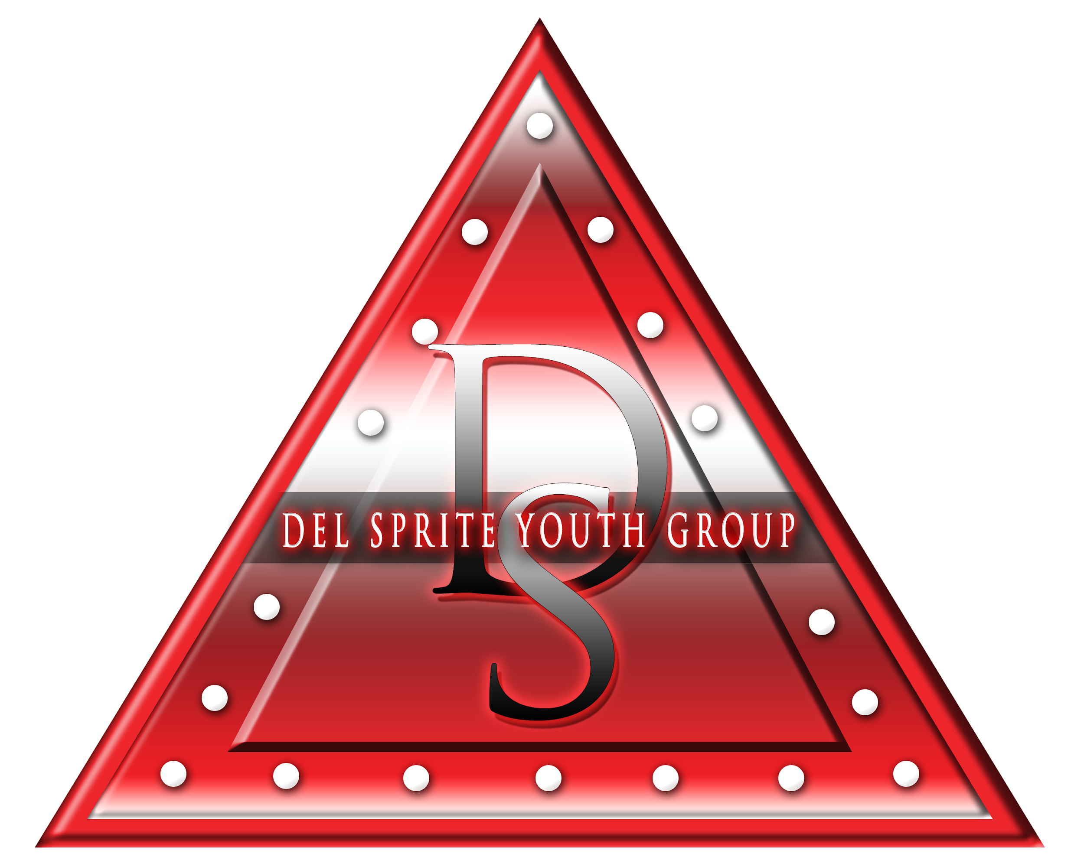

Reporting Committee: Del Sprite Youth Group

Committee Chair: Shalanda Ellison
Committee Members Present: Sorors D. Williams,T. Riggins, B. Vinson, K. Lawrence-Webster, K. Marshall, B. Fabin, S. Johnson

Del Sprite Youth Group
- 22 Active Del Sprites
- Upcoming Service Projects: NAACP Town Hall Meeting- Oct. 7;
Breast Cancer Walk- Oct. 13
- Rites of Passage series begins October 15, 2018- Etiquette
- Youth Symposium: Friday, November 16, 2018- Theme: Jersey’s & J.A.M.S

Recommendations by committee:
- Christmas Service Project
- Fill A shoe box” with suggested items (see list)
- Unisex or gender specific

- Mentorship Programs
- Sorors who have signed up to be a Sprite mentor should be risk- management cleared by Oct. 31
- Mentors will be assigned by Nov. 5, 2018

Best Items to Pack in the Christmas Shoebox

- crayons
- coloring books
- t-shirts
- ball
- bracelet
- pencils & pens
- pencil sharpener
- travel size games – checkers
- deck of cards
- harmonica
- yo yo
- Hat & gloves
- glue sticks
- small stuffed animal
- glitter
- small crafting kit
- post it notes
- highlighters
- small notebook
- chalk
- watercolor paint sets
- play doh
- small etch a sketch
- socks
- back pack
- plastic cup
- scarf
- jump rope
- glowsticks
- matchbox cars
- finger puppets
- silly putty
- toothbrush
- travel pack of tissues
- lip gloss
- hair ties
- hair brush/comb

